Subsystems
Subsystems are primary blocks for building the 1C:Enterprise interface. Therefore, the first thing to start with the development of a configuration is the design of the composition of subsystems.
At the same time, the developer faces an important and responsible task - to carefully consider the composition of the subsystems and then accurately and meaningfully bind the configuration objects that he will create to the subsystems.
In simple applied solutions it is possible not to use subsystems, but we recommend to use it always, because in addition to interface building, Subsystem configuration objects are intended to describe functional configuration parts, which represent logical parts of the applied solution.
Subsystems can be top-level and subordinate. The top-level subsystems are major interface items because they represent applied solution sections:
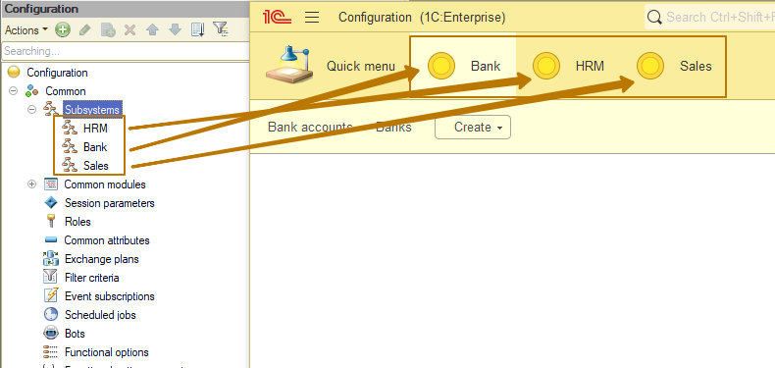
Previously, we created subsystems as part of the training. Let's create subordinate subsystems to better understand their purpose.
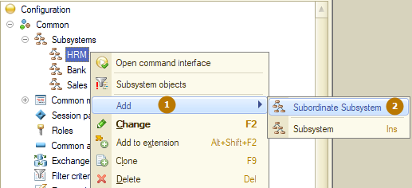

I will create a Company subordinated subsystem in the HRM subsystem in order to place objects related to working with the company, employees, personnel changes, etc. there. After creating the subsystem, I excluded objects from the HRM subsystem and added them to the new subsystem:
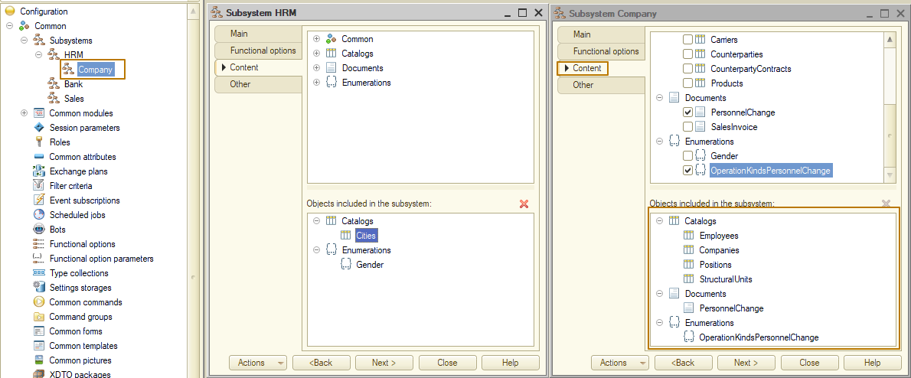
Let's update the configuration and see what has changed. Strange, visually everything remained as before.
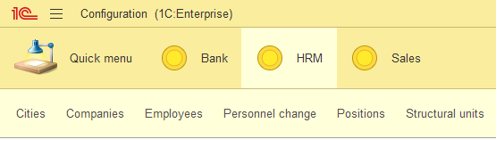
But if I click on an already opened subsystem second time, the view changes:
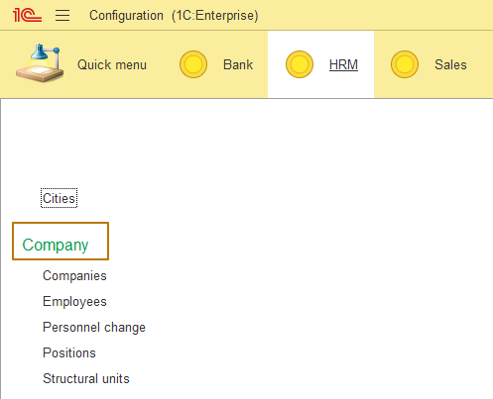
This is because subordinate subsystems are not displayed in the current section functions panel. We will cover the topic of panels later in the same lesson.
Each configuration object can be included in one or several subsystems. In other words, it will be available in each of the selected subsystems.
Looking ahead, we will mention that subsystems combined with visibility by roles allow developers to provide users with an easy-to-use and feature-rich interface free from any unnecessary items. For example, warehouse clerks need the ability to accept and issue products, but they have no need for anything related to accounting or service provisioning.
Thus, subsystems determine the applied solution structure, arrange the entire user interface, and enable sorting various documents, catalogs, and reports by logically related categories where users can find them easily. Note that users will only see the sections (i.e. applied solution features) that they need for their work.
Even for a small applied solution, we can define several functional components that represent distinct subject areas. We can put everything related to accounting into a single subsystem, and everything related to Sales to another subsystem. The same is for Purchases.
Information about storing and moving of products between warehouses, warehouse acts like inventory can be put to Warehouses subsystem.
And the need to perform administrative database operations suggests adding another subsystem that will only be available to the administrator. So even for small application we need several Subsystem objects.

Subsystem properties
Let’s consider the properties of the "Subsystem" configuration object. The flag "Include in the command interface" as you can understand from the name is responsible for whether this subsystem will be displayed in the interface. Some subsystems carry exclusively the function of functional separation to indicate the belonging of some metadata objects to a certain block and do not require display in the interface.
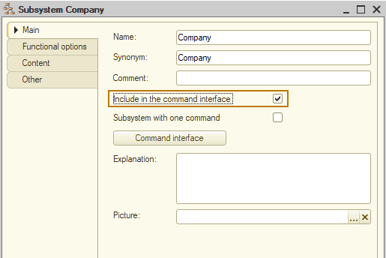
The “Explanation” field is used to display information about the subsystem as a tooltip on mouse hover.
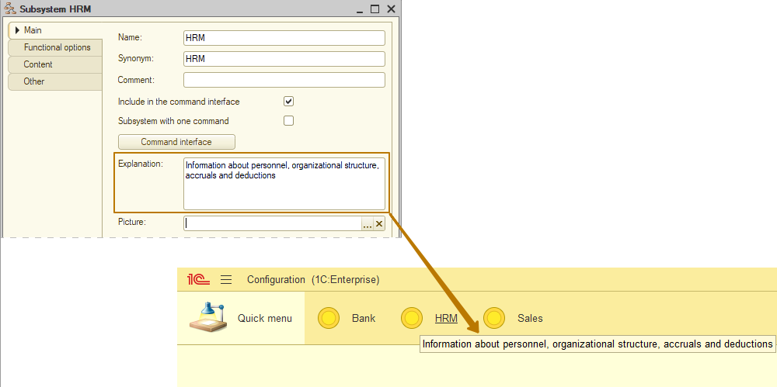
The "Picture" property is intended for displaying the image of the subsystem in the interface. Pictures are displayed only for top-level subsystems.
When specifying images of different sizes, the height of the sections panel will be calculated as follows:
- If there is at least one subsystem picture with a vertical size of more than 48 pixels, then all such pictures are proportionally reduced so that the vertical size is 48 pixels.
- If all pictures in the sections (subsystems) panel have a vertical size of less than 48 pixels, then the height of the section panel is calculated based on the maximum vertical size of pictures, and pictures with smaller sizes are centered in the areas reserved for pictures.
Let's add pictures for top-level subsystems:
- In the Picture field, click the selection button (1).
- In the Select picture window, on the From configuration tab, click Add (2).
- The platform creates a Common picture configuration object and opens its editor window. Click Load from file (3). Browse to the folder in the system, select the image file and click Open.
- In the Name field, enter the name of the picture. The selected picture is displayed in the common picture editor window.
- Close the Common picture configuration object editor.
- You can see that the list in the Select picture window now contains the picture that you added. Click OK (7).
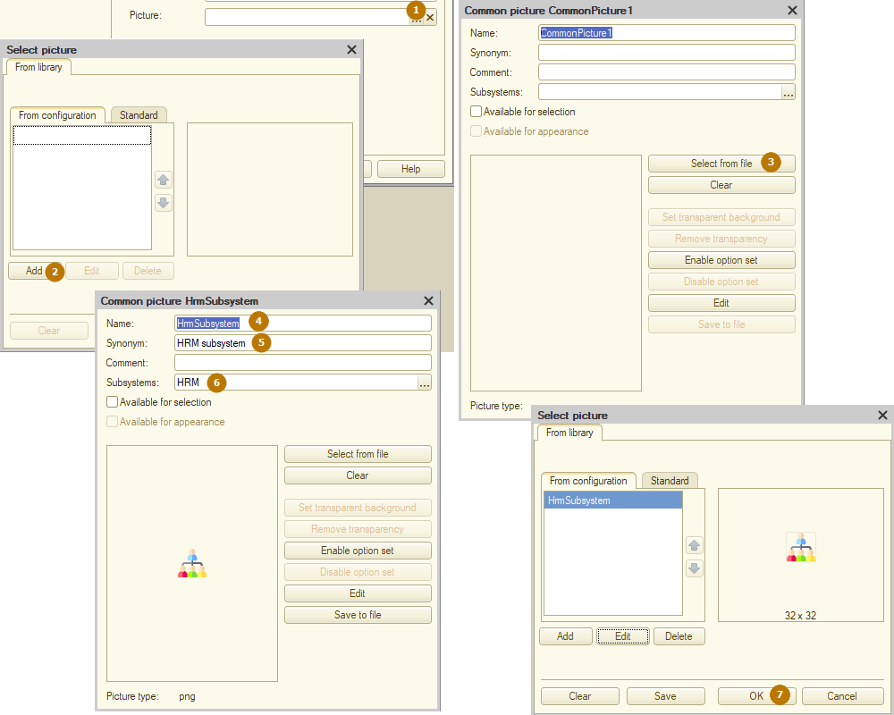
Once you are done, the picture is added to the Common pictures branch of the configuration object tree. You can edit this picture and use it in your configuration:
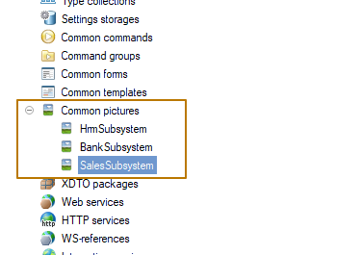
When you return to the subsystem configuration object editor, you can see that the picture you selected is now assigned as the subsystem picture.
In the 1C:Enterprise interface the subsystem synonym serves as the section name, while the picture is displayed near that name.
If a subsystem does not have a picture, the section is displayed in the interface with the default picture.
On the Content tab, you can include or exclude objects from the subsystem:
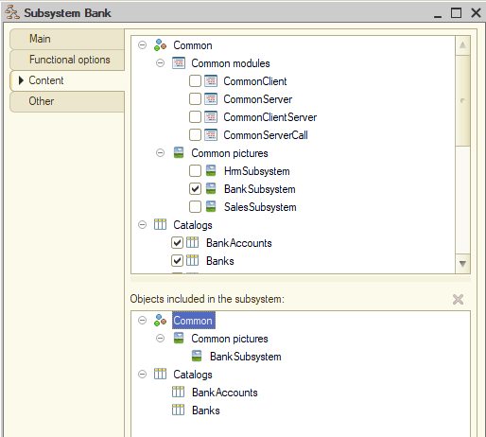
Panels
Let's consider the sections of the applied solution panels. Panels can be configured by the developer in the configuration as a default state for each user, and then each user can change the composition and location of the panels for themselves.
The composition of the panels is edited by the "Open client application interface" command from the context menu of the configuration. When creating a new configuration, the composition of the panels looks like this by default: Sections panel is located on top, below it is the Current section functions panel.
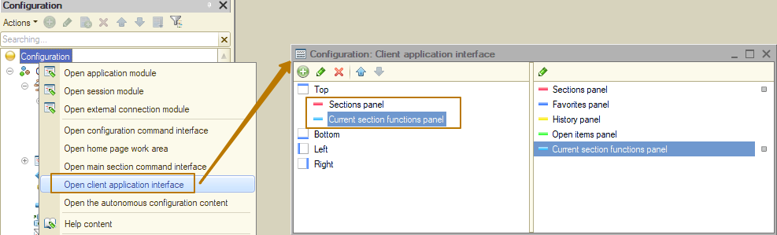
Now let's run the application in Enterprise mode and edit the composition of the panels
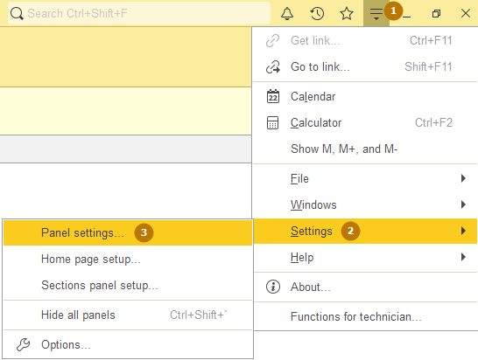
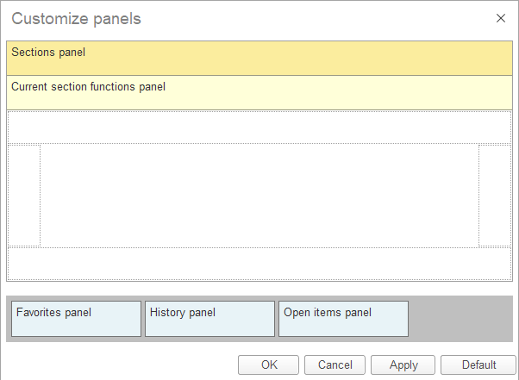
Panels are added and removed by dragging. I added all the panels to the interface and now I will explain their purpose
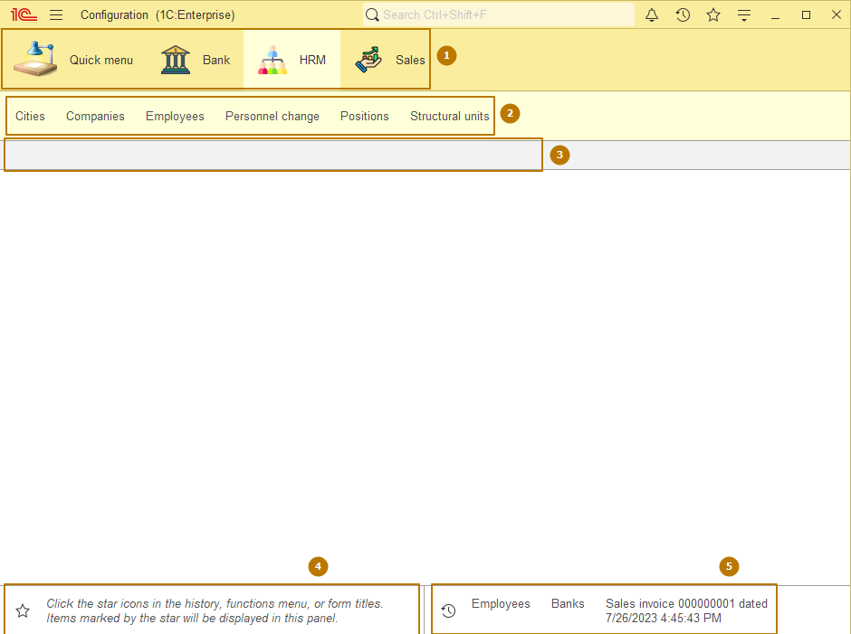
- Sections panel - a panel that displays the main sections of the application (top-level subsystems). The Quick menu section is generated automatically. It is designed to store documents, reports, and other items that are frequently accessed by users.
- Current section functions panel - displays the objects and commands included in the selected subsystem. If no subsystem is selected (by clicking), the panel remains blank. Usually this panel is disabled, because it does not contain division into subordinate subsystems and sections "reports" and "service", which the platform creates automatically when the subsystem contains reports and data processors.
- Open items panel - contains a list of all open forms. For example, if you open the list of banks from the Banks subsystem and the list of employees from the HRM subsystem and do not close these forms, they will be displayed on this panel. It's like open browser tabs
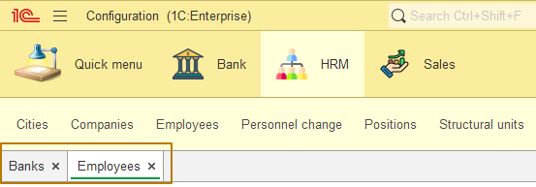
- The favorites bar contains items marked with a star by the user. Such a star can be enabled or disabled on the form near the header:
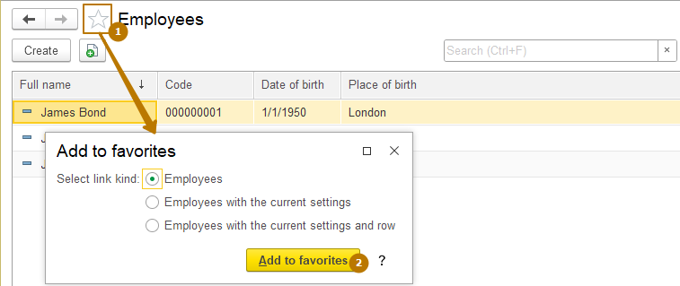
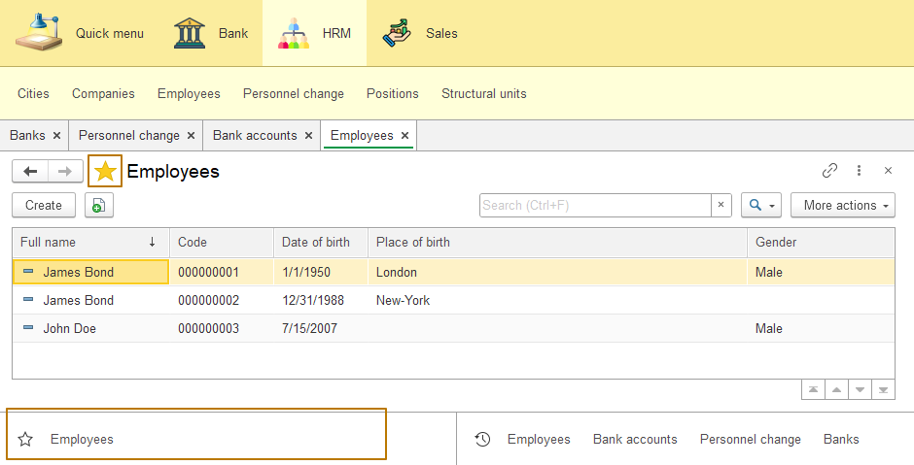
After adding a form to favorites, it can be opened from this panel instead of searching for frequently used forms, which saves time.
Also, the list of favorites can be edited by clicking on the star in the favorites panel. In the list that opens, you can attach and detach, rename objects, you can change their order by dragging them in the list, and also remove them from the list.
- The history panel keeps a history of the last opened forms. If you click on the watch icon on this panel, a list with more detailed information will open - the date and time when a particular form was opened. From this list, you can re-open forms, as well as manage your favorites - include or exclude.
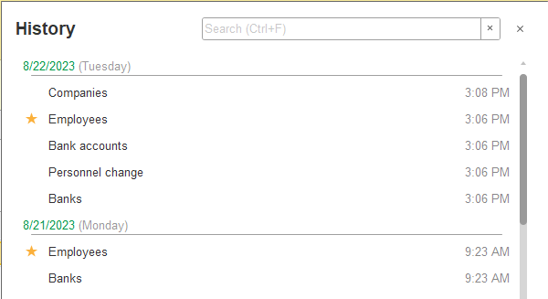
You can also use search (Ctrl + F to quickly go to the search box).
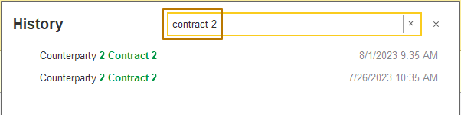

Forms
A form is an object created to input and view information, as well as to manage various processes. The application uses forms to ask the user for the required information, or to display data for the user to view and edit.
The main purpose of the form is to provide a user with a convenient means for entering and viewing information. Like a paper document, the form allows you to quickly enter the required information and save it for further processing, and if necessary, go back to the previously input data for viewing or correction.
The displayed part of the form (visible to users) is described as a tree that contains form items. Form items can be input fields, check boxes, radio buttons, regular buttons, and so on. Besides, an item can be a group that contains other items. A group can be represented as a framed panel, a panel with pages (tabs), a page itself, or a command bar. Moreover, an item can be a table that also contains items (columns). The item structure describes how the form will look like.
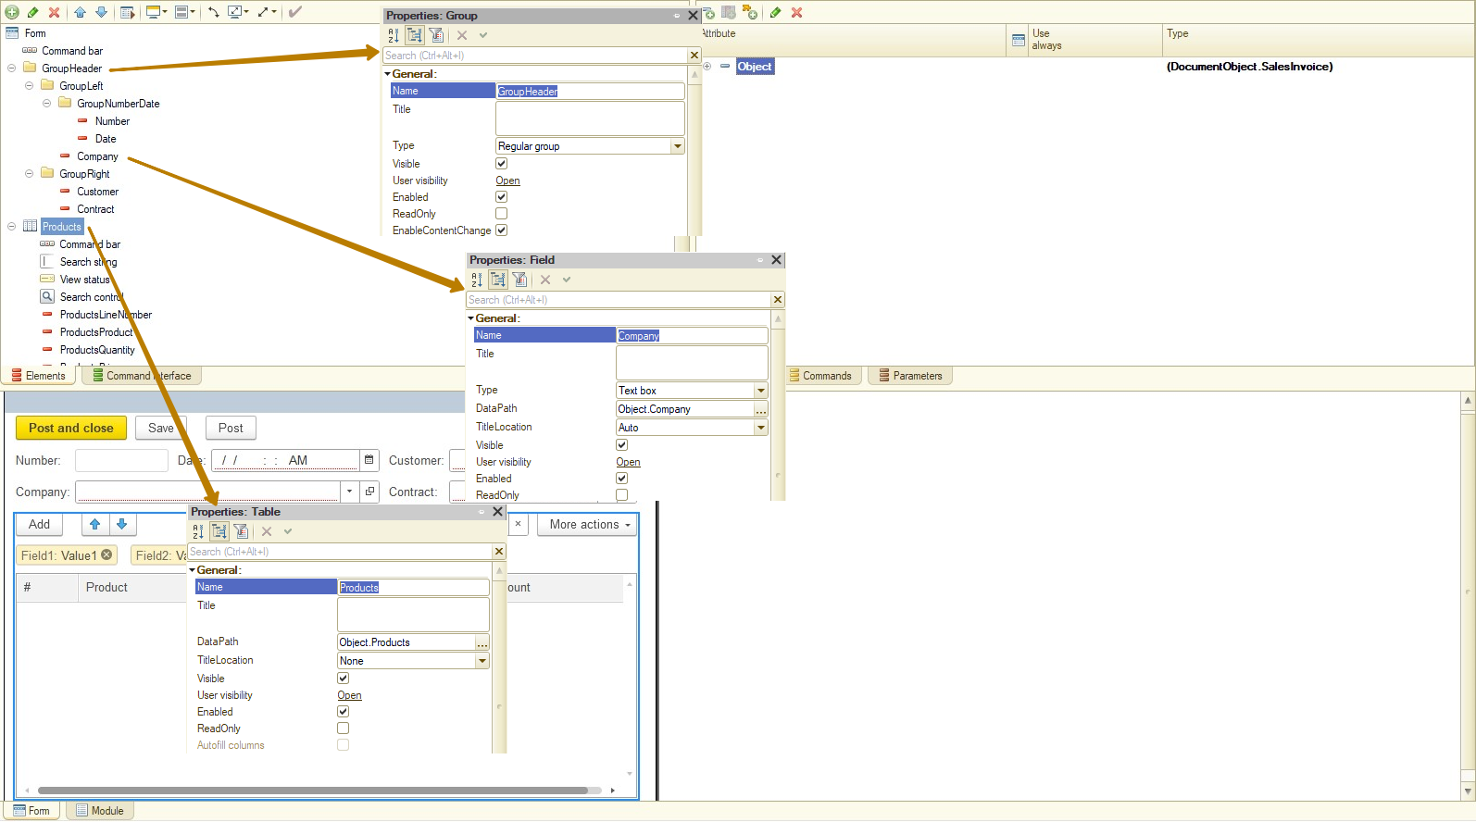On the other hand all the functions of a form are described by dint of attributes and commands. Attributes are the data that a form operates on, and commands are the actions it performs. Thus, a developer, by using the form editor, should include the desired properties and commands in the form, create the controls that display them and, if necessary, arrange the controls into groups.
The system can automatically create the form of an applied object, but developers are able to create a form themselves and to determine the composition of its properties, commands, and displayed controls. Drawing on this logical description, the system automatically shapes an appearance of a form, to display it for users. That said, the system takes into account various properties of the displayed data (for example, their type), in order to arrange the form controls as user-friendly as possible. The developer can fine-tune the item placement with various settings. They are able to define the order of controls, set their desired width and height. However, this is just some extra information that helps the system display a form.
In forms, a developer can use not only the commands of the form itself, but also the global commands used in the command interface of the entire configuration. Besides, an option to create configurable commands that will open other forms based on the specific data of the current form is implemented. For example, it may be a call of a stock balance report for a particular warehouse that is at the moment selected in the sales invoice form.
There is a feature in forms for attaching user messages to the form data. This allows the system to visually mark and activate form controls in which the user made a mistake when filling them in.
Also, the form automatically considers the role availability of data. For example, if a particular attribute of the displayed object is not available for viewing to a specific user, the system will automatically remove the form control associated with this attribute and then rebuild the form.
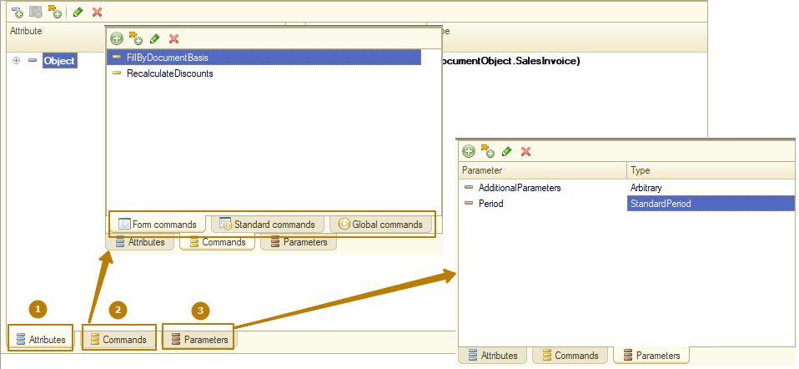
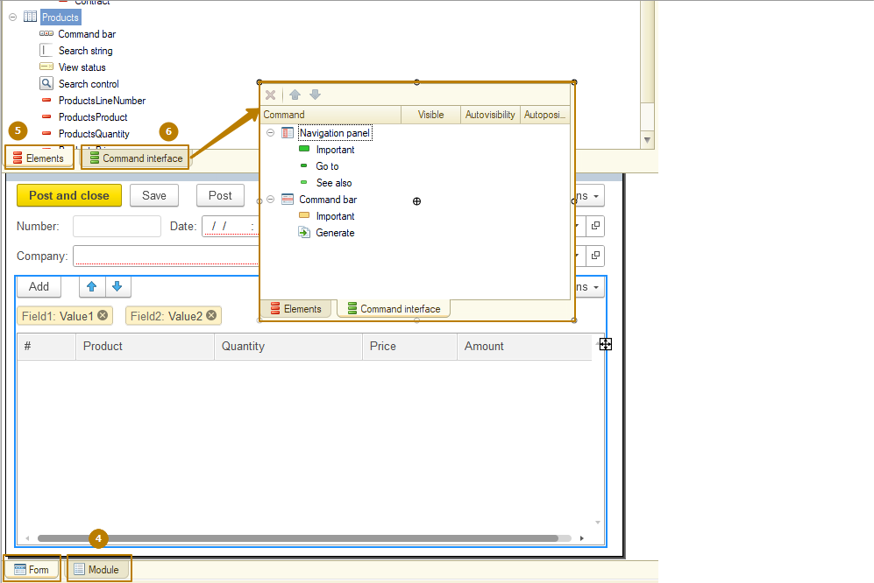
To create the form, use the form editor available in the Designer mode. In this editor, the following features can be defined:
- Form attributes. Intended for storing data that the form works with.
- Form commands. Intended for performing various actions within a form.
- Form parameters. Intended for arranging relations between the forms and controlling the functionality of the form when opening it.
- Form module. Contains the program code associated with the form functioning.
- Form items. Intended for displaying and editing form attributes, as well as displaying and running commands.
- Command interface. Contains commands that can be executed in a form and are provided by both the global command interface and the form commands. Adapting forms to the mobile client.
Note: Forms are present both on the server and the client at once. Always keep this in mind when designing a form.

Attributes
A set of form attributes describes the data that is displayed, edited, and stored in a form. All the same, the form attributes themselves do not provide options to display and edit data. Rather, the form controls associated with the corresponding form attributes are intended for displaying and editing the data. The set of all form attributes will be called form data.
Note: Keep in mind that all form data must be described as form attributes. It is not allowed to use the form module variables as data sources for the form controls.
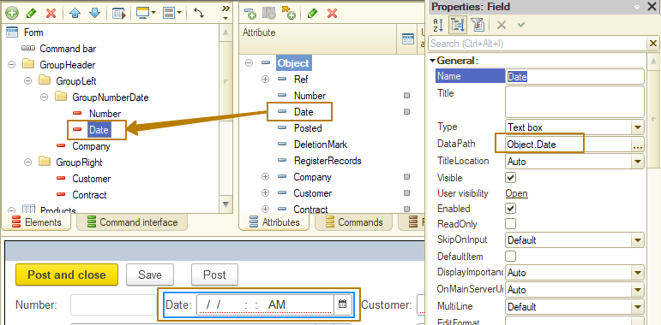
The availability of a certain attribute in a form can be configured using functional options (we will cover this topic later).
There is an option to assign the Main attribute of the form, which is an attribute that defines the standard form functionality (form extension).
Note: Keep in mind that a form can have only one main attribute.
The form extension comprises additional properties, methods, and form parameters of the ClientApplicationForm object that are specific to the main form attribute type.

The form operates with a limited set of data types:
- Types that are directly used in a form. They are types that are supported on both thin client and web client (for example, Number, CatalogRef.Items, GraphicalSchema, and SpreadsheetDocument).
- Types to be converted to special data types. They are form data types. Such types are displayed in the list of form attributes in parentheses, for example, (CatalogObject.Items).
- Dynamic list is a special data type that allows you to organize the display of arbitrary information retrieved from database tables in the form. To do this, specify the displayed table or describe the resulting selection in the query language. The tool is based on the data composition system and provides a set of options for sorting, selecting, searching, grouping, and conditional appearance of the received data.
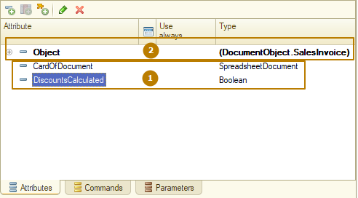
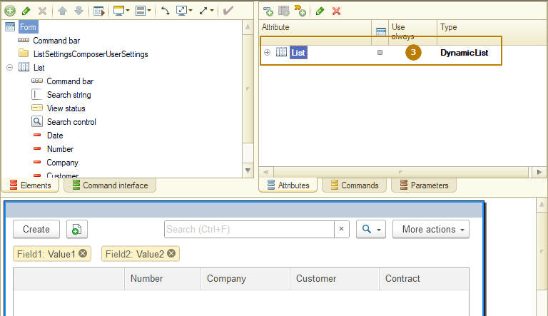
Some applied types (such as CatalogObject and so on) are not present on either the thin client or the web client. Therefore, for presentation of such applied types in the form, the platform has some special data types designed to work in forms. This feature makes it necessary to convert applied objects into form data (and vice versa).
The following data types are used:
FormDataStructure. Contains a set of attributes of arbitrary type. Properties can be other structures, collections, or structures with collections. For example, this type represents the CatalogObject in the form.
FormDataCollection. Array-like list of typed values. A collection element is accessed by index or ID. In collections derived from registry record sets or tables of objects, the LineNumber field of the collection element does not correspond to the actual index of the collection element. In some cases, there may be no access by ID, owing to the type of an applied object that is represented by this collection. Any integer can act as an ID. This type represents a table in the form.
FormDataStructureAndCollection. Object that is represented as a structure and a collection at once. It can be handled like either of these entities. For example, this type represents a record set in the form.
FormDataTree. Object intended for storing hierarchical data.
Important! It is not recommended that you use form data as parameters of procedures and functions that transfer control from the client to the server, and also as function return values if control is transferred to the client.
Important! When calling server procedures and functions and returning control to the client, only changes of data are transferred to the form.
An applied object is represented by either one or several form data items. On the whole, the hierarchy and composition of the form data depend on the complexity and interrelation of the applied objects of the form.
For example, a document containing a table will be represented by an object of the FormDataStructure type (document) to which the object of the FormDataCollection type (document table) is subordinate.
Note: When you design a configuration, keep in mind that applied objects are only available at the server, while form data objects can be used on both the server and the client.
When you create the form attributes, consider a number of restrictions:
It is forbidden to assign values of the Array and Map types to the form attributes.
- For the attributes of the arbitrary type of the objects, such as FormDataStructure, FormDataCollectionItem, FormDataTreeItem, FormDataStructureAndCollection, the assignment of values of the Array and Map types is not allowed.
- It is not recommended that use values of the Array and Map types as elements of collections of the Structure or ValueList type. In the above cases, use fixed collections: FixedArray and FixedMap.
- It is not recommended that you use the Structure and ValueList types in form attribute data (that is, in attributes of attributes).
- If a form attribute is of the Arbitrary type, or if a collection (array, map, and so on) is used as a value of such attribute, then do not set such attributes (or collection properties) to values that contain the following applied objects:
- DocumentObject
- CatalogObject
- BusinessProcessObject
- TaskObject
- ChartOfCharacteristicTypesObject
- ChartOfCalculationTypesObject
- ExchangePlanObject
- ChartOfAccountsObject
- ExternalDataSourceCubeDimensionTableObject
- ExternalDataSourceTableObject
In fact, we can say that form data is a unified presentation of data from various applied objects on which the form operates in a uniform manner, and which are present both on the server and on the client. That is, a form contains a certain projection of these applied objects in the form of its own data types and performs conversion between them if necessary. However, if a configuration developer implements their own data processing algorithm, then they must perform the data conversion (from specific types to applied types and back) independently.
When editing form attributes, you can influence the data transfer between the server and the client while the form is running. To do this, use the ”Always use” attribute editor column. The action of this property differs for the three types of attributes:
- For an attribute subordinate to a dynamic list (dynamic list column):
- The property is enabled. An attribute is always read from the database and included in the form data.
- The property is disabled. An attribute is read from the database and is included in the form data only when there is a currently visible form item associated with the attribute or its subordinate attribute.
- For an attribute subordinate to a register record collection:
- The property is enabled. Document register records are read from the database and will be present in the form data.
- The property is disabled. Document register records will not be read from the database and will not be included in the form data (if there is no form item that refers to document register records).
- For the rest of form attributes:
- The property is enabled. An attribute will be present in the form data, regardless of whether or not there is at least one form item associated with the attribute or its subordinate attribute.
- The property is disabled. An attribute will be present in the form data only if there is a form item associated with the attribute or its subordinate attribute. Unlike dynamic list attributes, the visibility of the item associated with the attribute does not matter in this case.
Note: Keep in mind that a property set for the parent attribute affects all its subordinate attributes. For example, if the ”Use always” property is cleared for the document table, then the system assumes that this property is cleared for all its subordinate attributes as well (despite the actual state of the property).
If the type description is displayed in parentheses in the attribute editor (the Type column), for example (CatalogObject.Products), this means that the applied type will be converted to the form data types.
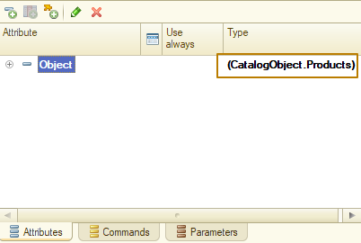
CatalogObject.Products here is not a real type of the Object attribute. The real one is FormDataStructure.
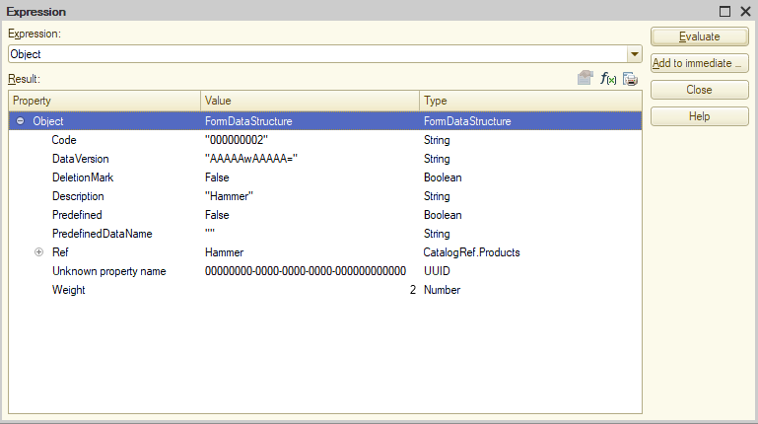
Let's take a look at some features of the form attributes belonging to various types:
- For form attributes of the ValueTable and ValueTree types, you can add columns (the Add attribute column command). This defines the data structure of the collection being created.
- For attributes of the FormDataCollection type (for example, object tables) and the FormDataStructureAndCollection type (for example, sets of register records), you can specify additional attribute columns (the Add attribute column command) that have no association with the data stored in the infobase.
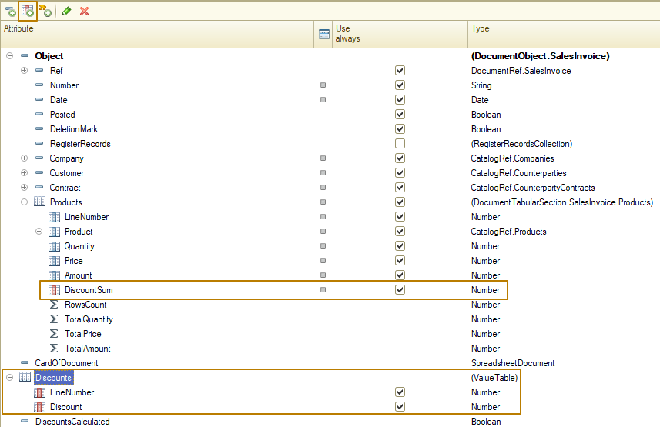
The system will create these columns as the form data is being generated. You can access such attributes both on the client and on the server.
Example of filling in an attribute column not associated with the form data:
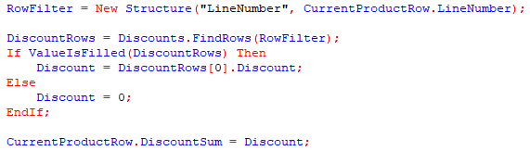
- For an attribute of the ValueList type, you can set the value type (the Value type property) that will store the list. At the same time, the system will automatically limit the type of data to be added when adding interactively. Also, programmatic addition is not prohibited, yet an attempt will be made to cast the value of the type being added to the limiting type (or flexible type). You can also associate the Value type property with a form item and interactively limit the data types that can be added to the value list.
- For an attribute of the DynamicList type, you can set up list parameters: main table, settings, and so on.
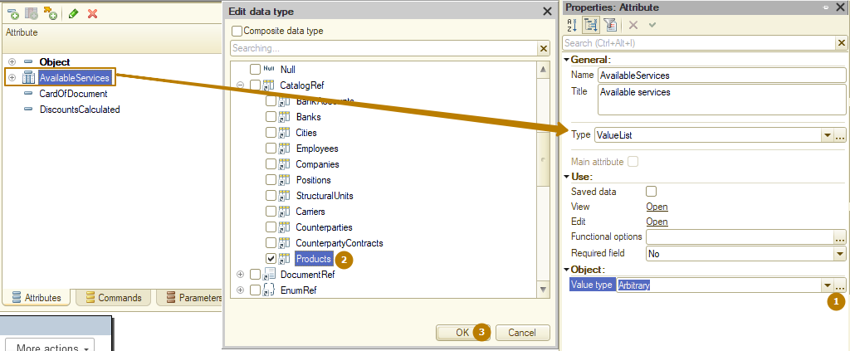
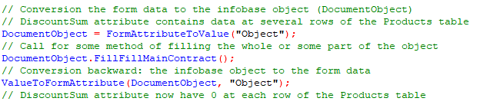

Converting applied object data to form data and back
There is a set of global methods for converting applied object data to form data and back:
- ValueToFormData()
- FormDataToValue()
- CopyFormData()
Methods that work with applied objects are available only in the server procedures. The method for copying values between form data is available both on the server and the client, since it does not require applied objects as parameters.
When converting form data to an applied object, consider their compatibility.
- ValueToFormData(). Converts an applied object to form data.
- FormDataToValue(). Converts form data to an applied object.
- CopyFormData(). Copies form data with a compatible structure. Returns True if the copy is successful. Returns False if the object structure is incompatible.
When converting form data to applied objects and back, objects are cached and the cached object version is checked for relevance.
Note: When executing standard actions (opening a form, running a standard Write command, and so on) in a form with the main attribute, the conversion is performed automatically.
Let's take an example of how to use data conversion in native algorithms.
&AtClient
Procedure WriteObject();
WriteObjectAtServer();
EndProcedure

&AtServer
Procedure WriteObjectAtServer()
ObjectItem = FormDataToValue(Form.Object, Type("CatalogObject.Items"));
ObjectItem.Write();
EndProcedure
Also, the ClientApplicationForm object has methods available on the server
- ValueToFormAttribute(). Converts an applied object to the specified form attribute.
- FormAttributeToValue(). Converts a form data attribute to an applied object.
In most cases, using FormAttributeToValue is preferable to FormDataToValue at form modules.
Sticking to this recommendation will help you to keep the code consistent with other 1C:Enterprise applications. Also, FormAttributeToValue has simpler syntax, than FormDataToValue, so there is a less chance to make a code mistake.
FormDataToValue requires the data type to be specified explicitly.
Products = FormDataToValue(ProductsTable, Type("ValueTable"));
In contrast, FormAttributeToValue doesn't require data type to be specified.
Products = FormAttributeToValue("ProductsTable");.
When converting objects of the ValueTable or ValueTree type to form data using either the ValueToFormData() or ValueToFormAttribute() method, note that the object to be converted must contain all form data columns.
Important! Attribute columns that are not associated with the data do not participate in the conversion of values between the form data and the infobase objects, and vice versa. Columns that are missing in the object data are cleared when converting to the form data.
Only form attributes of the following types can be used as the first parameter of the FormAttributeToValue() and FormDataToValue() methods:
- FormDataStructure
- FormDataCollection
- FormDataStructureAndCollection
- FormDataTree.

Example:
&AtServer
Procedure CalculateTotalAtServer()
// Convert the Object attribute to an applied object.
DocumentObject = FormAttributeToValue("Object");
// Perform recomputing by the method defined in the document module.
DocumentObject.CalculateTotal();
// Convert the applied object back to an attribute.
ValueToFormAttribute(DocumentObject, "Object");

EndProcedure

Attribute properties
Let’s take a look at some properties of the form attributes.
Title is a text that is used as the title of the form item associated with this attribute if the Title property of the form item is not specified explicitly.
Main attribute determines that the given form attribute is the main one and thus determines the form extension.
Saved data. If this property is set to an attribute, then interactive modification of such attribute will result in:
- Attempt to block the associated form attribute.
- Turning on the “Modified” property of the form.
- If the attribute has the ”Saved data” property enabled and the form is in the ”Read only” mode, then all form items associated with this attribute will also be in the ”Read only” state.
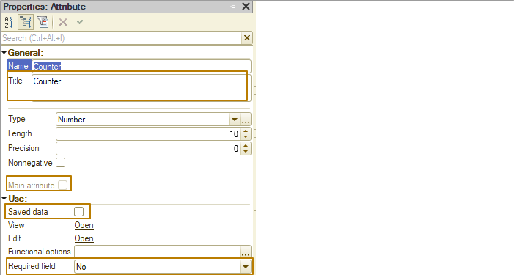
Required field. Determines whether it is necessary to check this attribute for filling (the property value is Display error). The Fill check is available only for the attributes of the following types:
- Primitive data types (Number, String, Boolean, Date, any types of references, standard period)
- Value list
- Value tree
- Value table
Note: Attribute filling is checked similar to the ValueIsFilled() function. The table filling check implies that a table is considered to be filled when it contains at least one row.

Form parameters
Form parameters (the Parameters tab) serve two purposes:
- Describe the data set that will affect opening of the form (parameterization). To do this, list all the necessary parameters and specify their kinds.
- Determine the parameters that will affect a key of the uniqueness of form. For this, set the Key parameter property for those parameters that should participate in the formation of the form uniqueness key. When trying to open a form, the system searches for an existing form using the previously generated form uniqueness key. If there is a form with the received uniqueness key in the system, then this form is returned. If not, a new form is created.
When calling a form, the values of the parameters created by a developer can be specified in the parameters structure along with the system parameters of forms (if any).
Form parameters can be transferred to a form at the time of its creation. You can analyze the transferred parameters in the OnCreateAtServer() event (the Parameters collection is a property of the ClientApplicationForm object):
At the place of the call:
// Generate a form parameter.
Parameters = New Structure();
Parameters.Insert("PickMode", PredefinedValue("Enumeration.PickModes.Simple"));

// Open a form with specified parameters.
OpenForm("CommonForm.PickProducts", Parameters);
In the form module:
&AtServer
Procedure OnCreateAtServer(Cancel, StandardProcessing)
// Check if the form contains such a parameter
If Parameters.Property("PickMode") Then
If Parameters.PickMode= Enumerations.PickModes.Simple Then
…
EndIf;
EndIf;
EndProcedure
Important! After the OnCreateAtServer event handler are called, all non-key form parameters are removed from the Parameters collection.
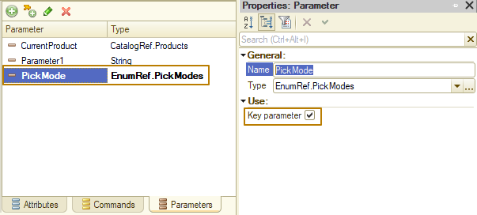
key parameters are highlighted with bold font in the list
Note: Non-key form parameters that are necessary for further work can be stored in the form data.
When working with form parameters, keep in mind that the behavior of the parameters can be considered equivalent to the system behavior if the parameter value is not explicitly specified (skipped) when calling the 1C:Enterprise language method. In this case, the parameter value will be set to Undefined (or the default value). The form parameters behave similarly: if the parameter is set when the form is opened in the client application, this parameter will be present in the form parameter structure with a set value. If the parameter is not specified when the form is opened then the platform will automatically add the parameter in the structure of parameters but the value of this parameter will be Undefined. It is equal to skipping the parameter upon the method call. The behavior described above is the same both for the parameters created by the developer and the standard parameters of the form.
To support automatic interaction between forms, the system provides a number of standard parameters that are used to manage forms when they are opened. Using these parameters, the system implements a selection in the form fields from the selection forms, opening of object forms, operation of the standard commands, and so on. That is, they provide various scenarios for the operation of interface embedded in the system. However, the developer can also use these parameters in 1C:Enterprise language by passing them when calling the OpenForm() method.
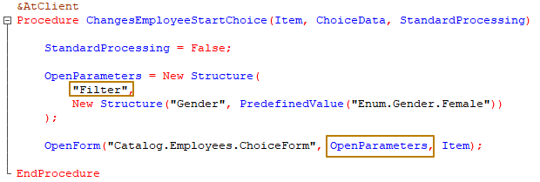
To see the list of the standard form parameters depending on the form extension type, in the built-in help, go to Help - Interface (managed) - Client application form - Client application form extension for...
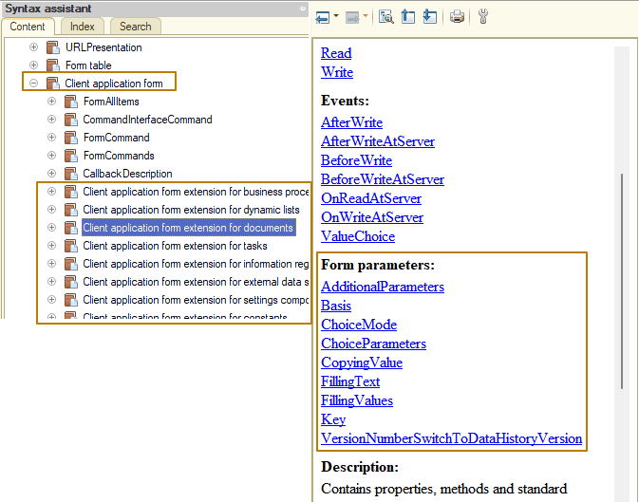
Note: For list forms and choice forms see “Client application form extension for dynamic lists”, because the type of the main attribute of such forms is a dynamic list.

Form commands
The form actions are performed using form commands. The commands themselves serve only as a description of the actions performed. In order for a command to perform its function, it must be tied to a form item (such as Button) There are several groups of commands that are present in the form:
- Commands created by developer in the form design process. For them, a handler needs to be created directly in the form module.
- Standard commands that are provided by the main form attribute extension and extensions of attributes that are lists (for example, an object table, a dynamic list, an information register record set, and so on) if there is a form item associated with this attribute.
- Global commands that are provided by the global command interface. Such commands may be both non-parameterized and parameterized. Parameterized global commands will be provided to a form only if there are sources of parameters with the corresponding types on a form.
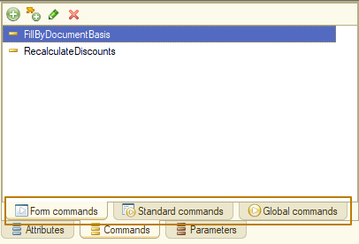
The availability of standard form commands and the form items is determined by the ”Command set” property of the corresponding form item.
For example, let’s turn off “Mark for deletion” and “Delete” buttons from the command bar of the Sales invoice document.
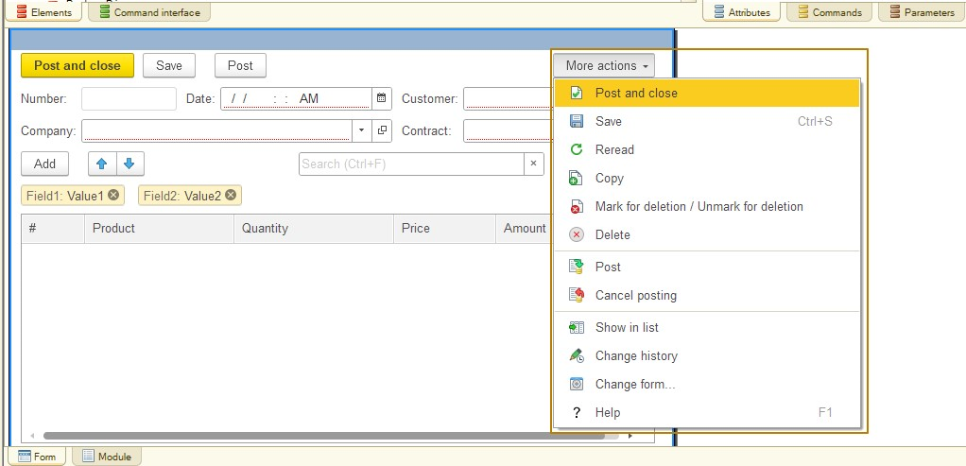
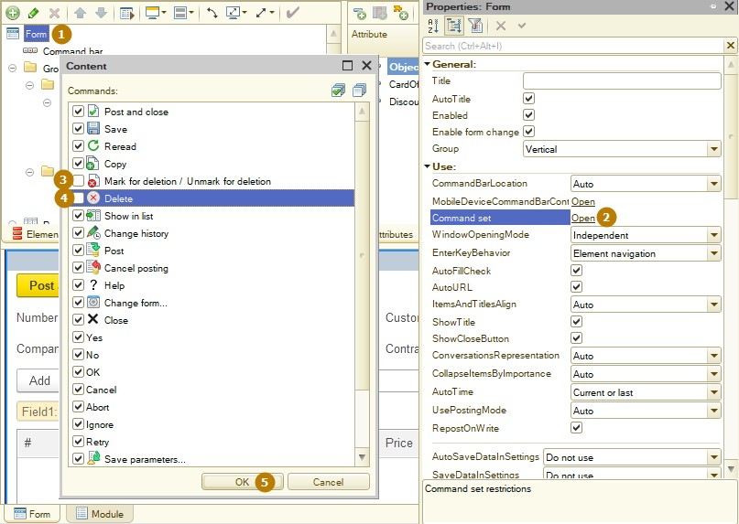
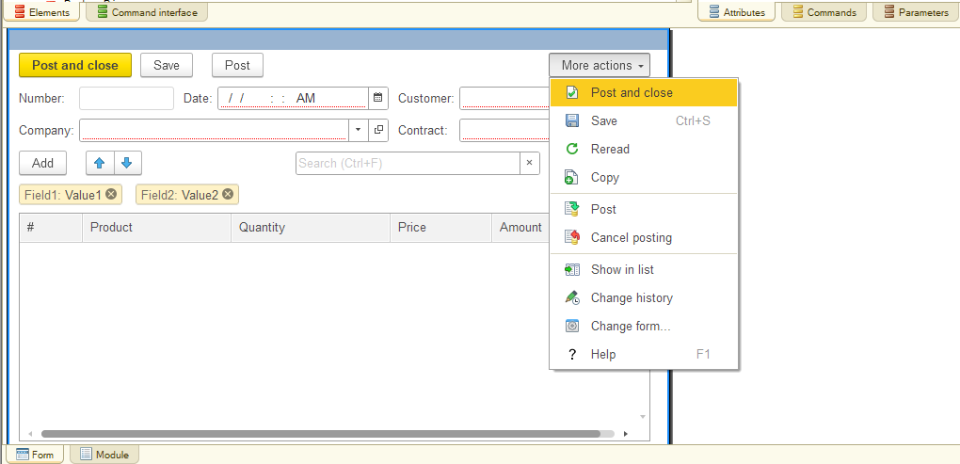
The commands provided by the global command interface (the Global commands tab) can be placed anywhere on the form, just like the form commands.
The Action property specifies a handler that implements the action performed by a command. If a handler is not specified, a command will not be available for use. Only client-side procedures and functions with one parameter are available for selection in this field.
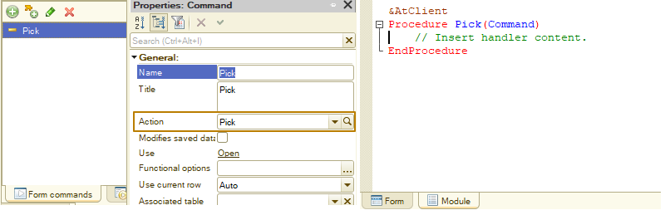
If a command changes the form data, then indicate this by setting the ”Modifies saved data” property. Then when you try to execute the command, the following will happen:
- An attempt is made to lock the main form attribute. If the attempt fails, the command will also fail.
- The “Modified” property will be turned on for the form.
If the ”Modifies saved data” property is set for a command and a form is in the Read-only mode, then all the form items associated with this command will also be in the Read-only state.
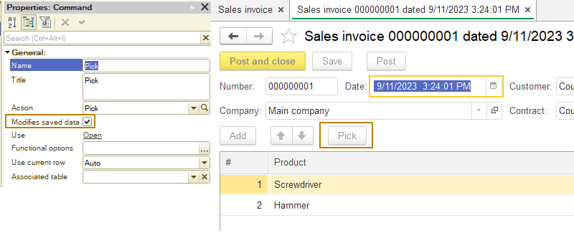 In addition, executing a parameterized global command, for which the parameter is provided by the attribute with the ”Modifies data” property set, for a new and unsaved object will result in an attempt to write an object. In this case, the user will be asked if they want to write the object. If the answer is negative, the command will fail.
Note: When you automatically fill in command bars and context menus for which the command source is specified, the standard commands are not added if this item has buttons added manually with the same commands. This logic does not apply to commands added from a fragment of the global command interface.
If a command has disabled “Use” property, then all associated buttons are missing from the command interface. The user cannot change this setting.
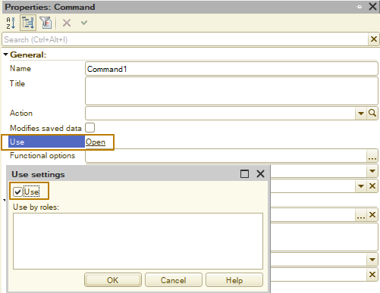

Form items
The visual representation of a managed form is described by a set of items. Form items form a hierarchical collection. The hierarchy of form items determines the appearance and composition of the controls displayed on a form. There are several types of form items:
- Form, which is a root item of the item tree and exists in a single copy
- Form field
- Form decoration
- Form table
- Form button
- Form group
- Form item add-on
Form items of the form field and form table types are always associated with form data. If the associated attribute is not specified, or it is not available on the client due to rights restrictions, or it is excluded from composition (the View and Edit properties of the form attributes), the field will not be visible on the form and will be automatically deleted when the form is created in Enterprise mode.
Each form item is described by a certain set of properties that determine its behavior on the form, including the display and transformation features such as changes in the item size when the form or surrounding items are resized (including either disappearance or appearance of items).

General properties of form items
The TitleLocation property determines how the item title is displayed. The title is a synonym for the form attribute associated with the selected form item, unless the Title property is specified for the form item. The title always ends with ":" (automatically added by the system).
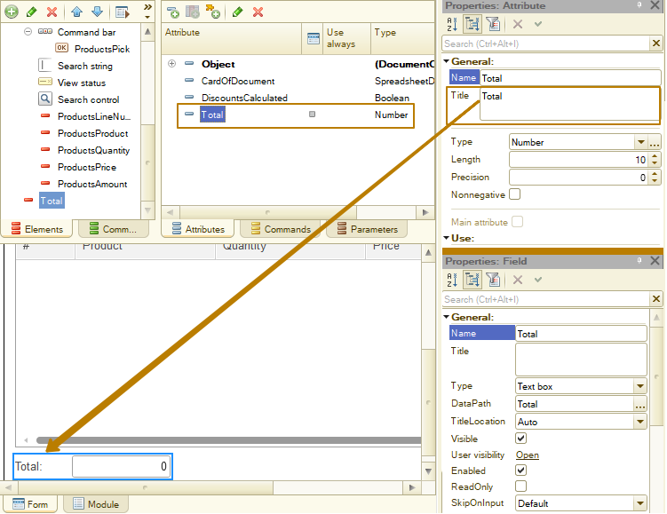
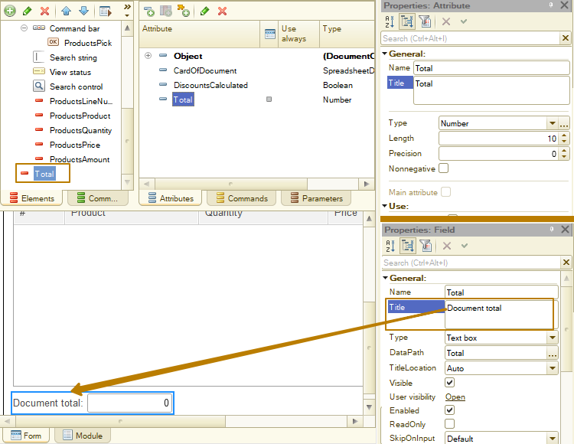
When you add an item in the Data property, specify a reference to the form attribute with which this item is associated. If the form item is not associated with the form attribute, then it will not be displayed on a form. If you add a button to a form, then in the Command property, specify a reference to the command that will be executed when the button is clicked. If the button is not associated with the command, then it will not be displayed on the form.
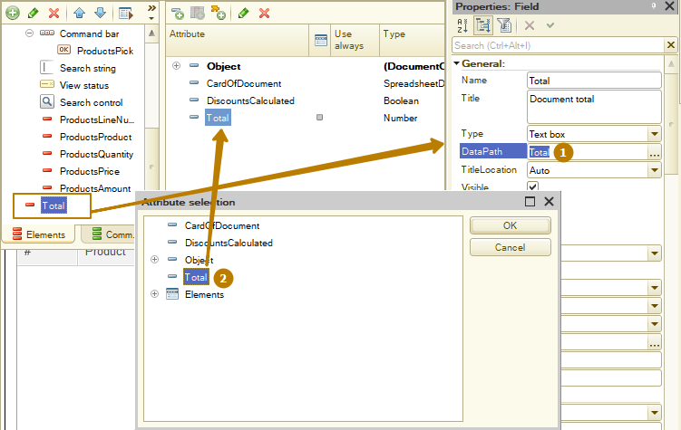
A form item can be in the Read-only mode (prohibiting any changes) if it has the ReadOnly property set (in Designer or using 1C:Enterprise language), or if the group to which it belongs has the ReadOnly property set, or if the attribute associated with it has the SavedData property and the form is set to the Read-only mode.
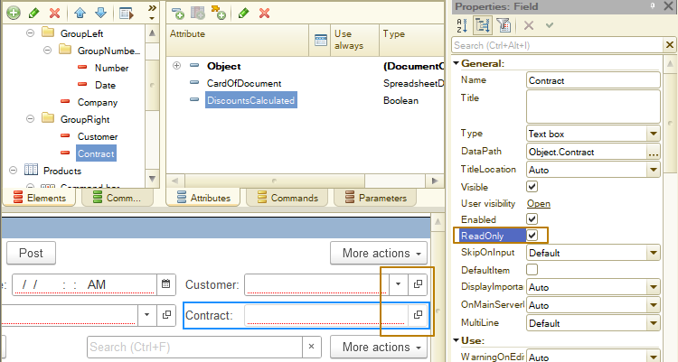
In the example above the Customer item is available for editing, but the Contract item is not, since its ReadOnly property is enabled. Therefore the field frame has a lighter color and there is no select button, just an open button.
Visibility of form items is controlled by two properties: Visible and User visibility. The first property can be changed both in the form editor (in Designer) and from a code. The User visibility property is configured only in Designer and sets the initial visibility of a form item broken down by roles. The resulting visibility of the form item is formed by “AND” operator of the Visibility and User visibility properties for a specific user.
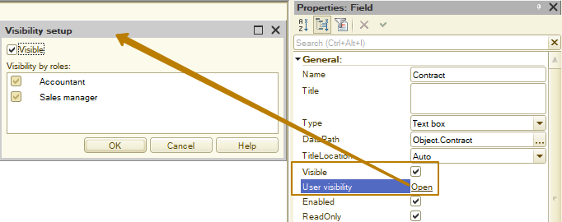
In addition, by changing the visibility of form items in the Customize form dialog box, the user actually changes the User visibility property of a particular form item.
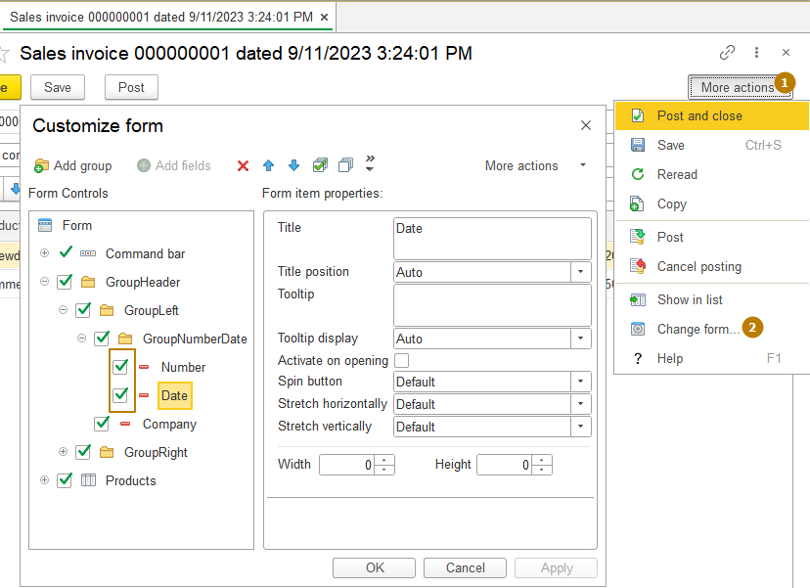

Associating items with form attributes
Let's look at some special modes of form elements connection:
Connection to current data of tables
A form item can be associated with an attribute representing a column of a table placed on a form. In this case, this item displays the data fields of the current table row. Such connection is allowed for both fields and tables. It is not required that the corresponding column be displayed in the table. The item associated with the current data can be in either the Read only mode or the edit mode.
For example, you need to place a field on the form that displays the price for the current row of products. To do this, add a field to the desired place in the hierarchy of form items (the type of input field can be either Label field or Input field), for which select (in the Attribute selection dialog box) Elements.Products.CurrentData.Price as a data path. Here Elements is a property of a form that contains all form items, Products is a form table with the data of a document’s tabular section, CurrentData is a path to table current row and Price is a table attribute.
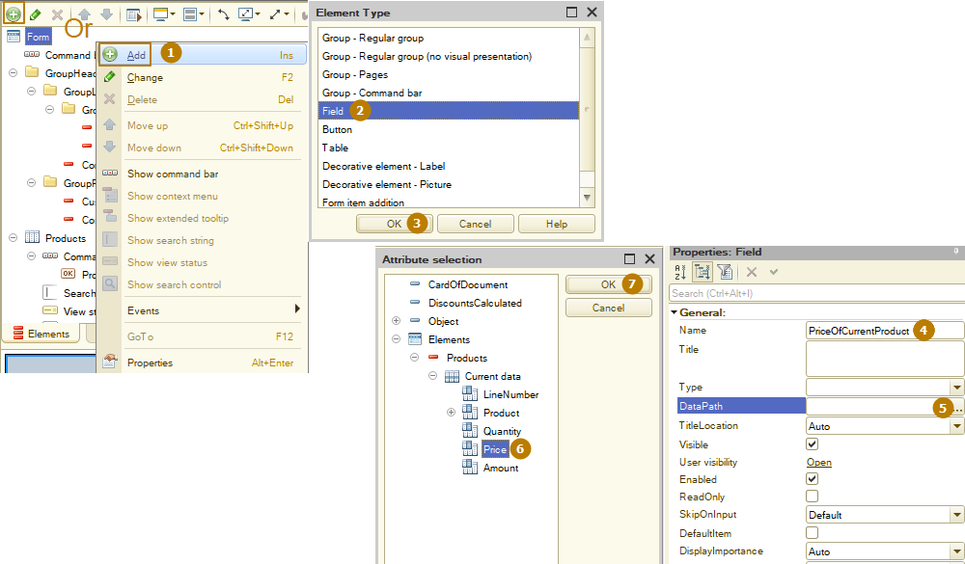
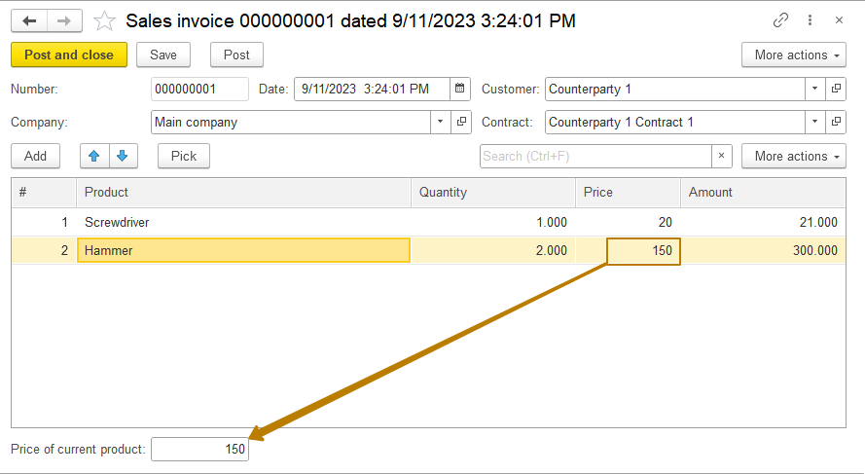
Connection to attributes through reference
If there are attributes of reference types in form data (for example, CatalogRef), then the form item can be associated with the attribute received by this reference. Data for such items will be received automatically and updated when the reference changes. Connection with attributes through a reference can be of any depth. Items associated with such attributes are always in View only mode.
Note: For attributes of a composite type (several types, including such types as CatalogRef, DocumentRef, and so on), it is not possible to receive attributes through a reference.
For example, we need to place a field on the form that displays the weight of the product of the current table row. To do this, add a field to the form table. For the field, select Object.Products.Product.Weight. Here Object is a form attribute of the Document type of a specific document, Products is a document tabular section, Product is a table attribute (CatalogRef.Products type), and Weight is an attribute of the Products catalog.
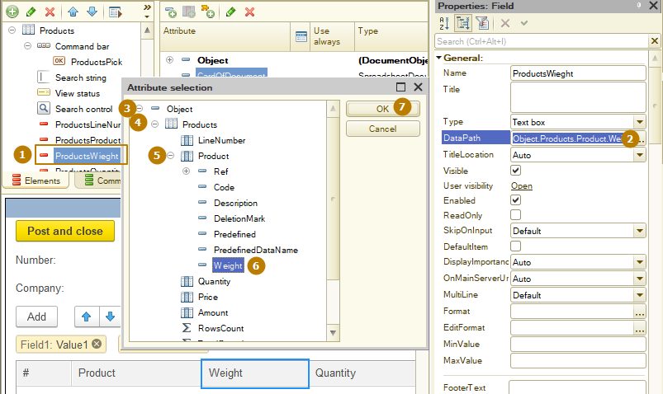
Connection with collections totals
A form element can be associated with attributes, which are the total values of some collections: tables, record sets, value lists (only the number of rows in the collection). Such attributes can be:
- Totals by number fields
- Number of rows per collection
- Items associated with such attributes are always in View only mode.
As an example, put on a form the field displaying a sum total for the tabular part Products. To do this, specify Object.Products.TotalAmount as the form field data, where Object is a main form attribute, Products is a document tabular section, and TotalAmount is a special attribute (it’s a total of the Amount column of the table). Connection can be established not only for the item itself.
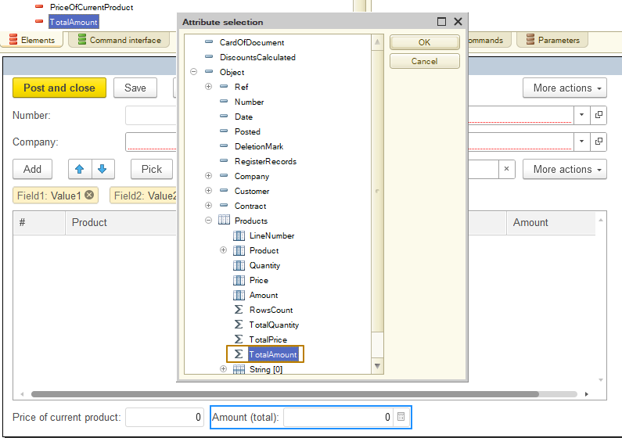
You can also set a link to display data in the table footer and the tab header (groups of the Page kind). To display totals in the column footer, you must enable the footer display for the table by enabling the Footer property and then fill in the FooterDataPath property of the column. To display the number of table rows in the tab title, you must fill in the TitleDataPath property of the group with the Page type.
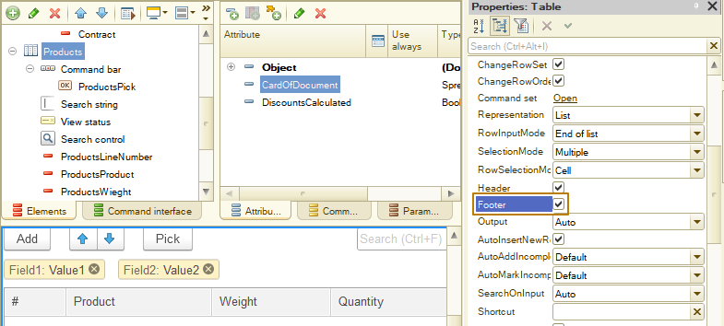
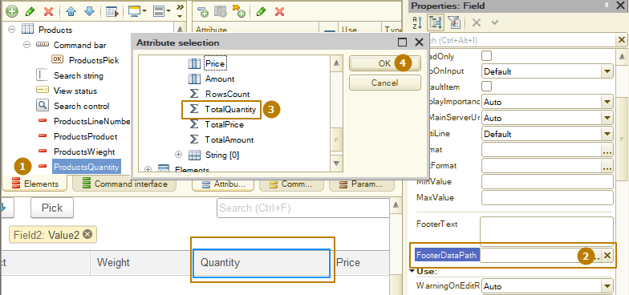
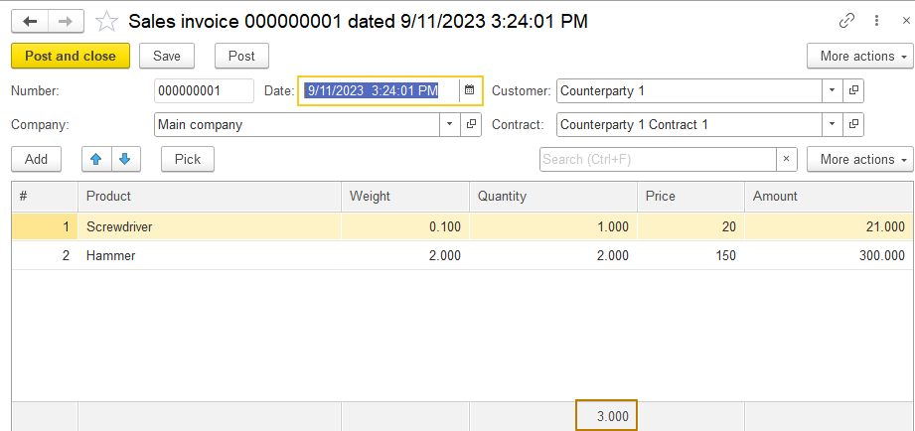

Choice parameters
This property allows setting the parameter values, which will be used when choosing the attribute value. Choice parameters will be performed when opening the choice form, when displaying the quick choice list and when inputting by rows. For example, the choice has to be limited by the products with Type attribute equal to Enumeration.ProductTypes.Product value.
Values specified in this property will be transferred to the opened form via the Parameters structure. The Name column value will correspond to the structure element key and the Value column - to the structure element value. If the Name column includes the ”Filter.Type” value, the Filter form parameter will be created (Structure type). The item with ”Type” key and ”Product” value will be created in this structure.

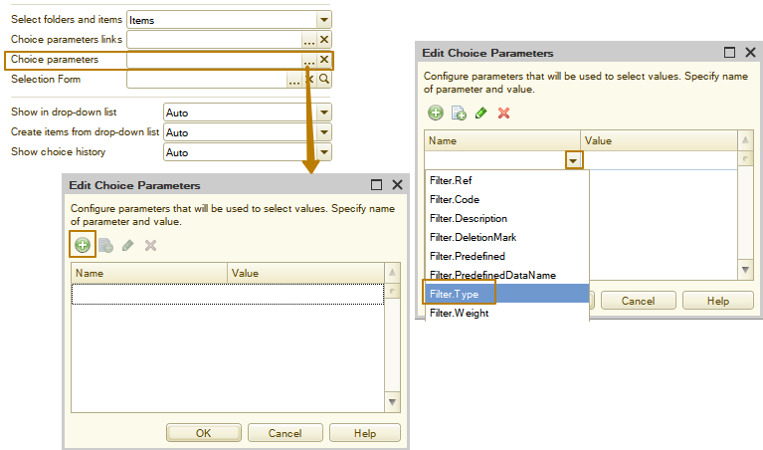
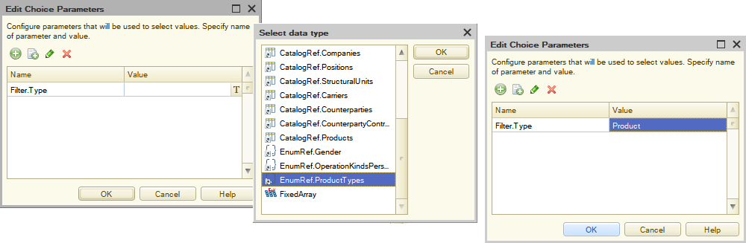
The value list can be specified for the specific filter. To do this, choose Fixed array type when editing the Value column.

Form
It describes visual properties of a form. An item of this kind always exists in the singular and it is at the root of the item hierarchy. Form properties also describe form event handlers.
When you open a form, it is possible to interrupt this process in several places:
- OnCreateAtServer event handler. Changing the service parameter Cancel to True in this handler will result in the form not being created at all.
- OnOpen event handler. Changing the service parameter Cancel to True in this handler will result in the form not being opened.
To control the form opening mode, use a special property - WindowOpeningMode.
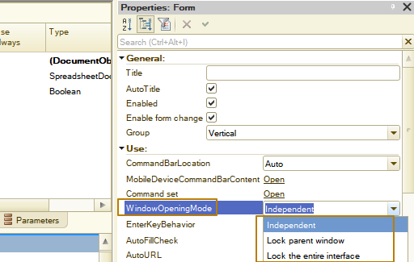
This property describes how a window will be opened:
- Independent. A form opens in the working area of the main application window.
- Lock parent window. The form opens in a non-modal window when work with the form from which the opening of the current form was initiated is blocked. This mode is intended for forms in which little information is entered and work with which does not require a long time. For example, to enter items of catalogs containing a small number of attributes. This mode is externally similar to the modal opening of a form; however, when opening from the 1C:Enterprise language, the operation of the module does not stop for the duration of the opening form. In this case, all other interaction with a form is performed as with other non-modal forms. This form also opens in an auxiliary window. This mode is set by default for the following forms:
- Catalog item and group
- Exchange plan node
- Item and group of a chart of characteristic types
- Account
- Calculation type
- Task
- Record of an independent information register
- Lock the entire interface. Similar to the form that opens in the ”Lock parent window” mode, but both the parent form and the entire application interface are locked. This opening mode is not used as a default setting.
When a form is opened in blocking mode, the following algorithm for determining the blocking window is used:
- If a form is set in the FormOwner property and this form is not closed, a window of this form is blocked.
- If a form item is set in the FormOwner property and this form is not closed, the form window to which this item belongs is blocked.
- In other cases, if the FormOwner property is set to Undefined or the owner form is closed, the window that is the current window of the client application at the moment of opening the form is locked.
The Window opening mode property does not affect the form opening from a form blocking the interface. In this case, the WindowOpeningMode parameter of the OpenForm() method will also be ignored. The form will open in a separate window, in the non-blocking mode.
For a form, you can display a command bar (its location on the form can be controlled using the ”Command bar location” property).
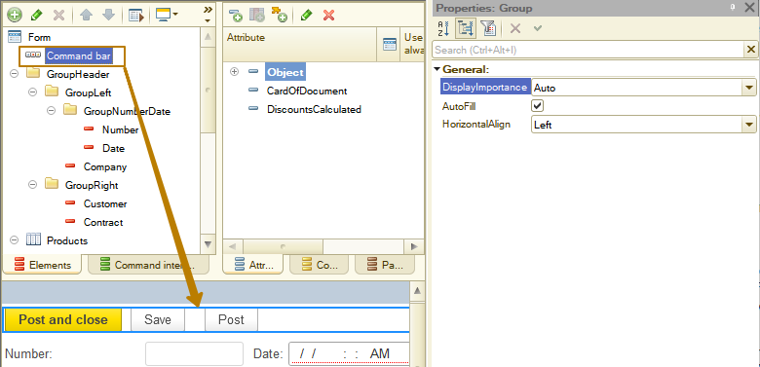
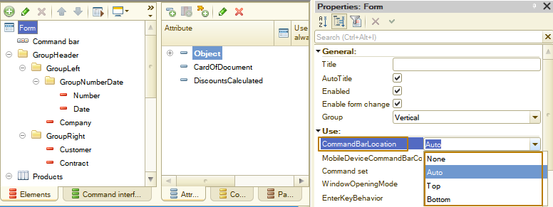
The set of standard form commands can be adjusted using the ”Command set” form property.
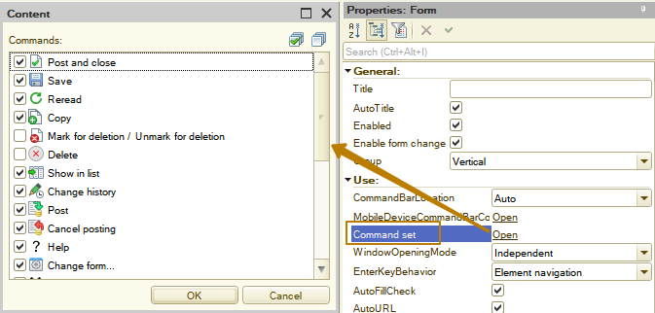
If the Enable form change property is turned off, then the user cannot change the set and relative position of the form items in 1C:Enterprise mode.
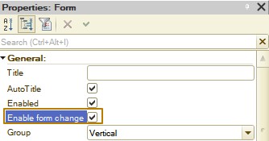
To set the View only mode, the form has the ReadOnly property that is available only for programmatic changes. If this property is set to True, then the following form elements will become unavailable:
- All items associated with attributes with the "Saved data" property enabled
- Buttons associated with commands with the "Changes saved data" property enabled
- Buttons associated with most standard commands
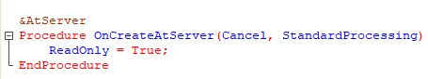
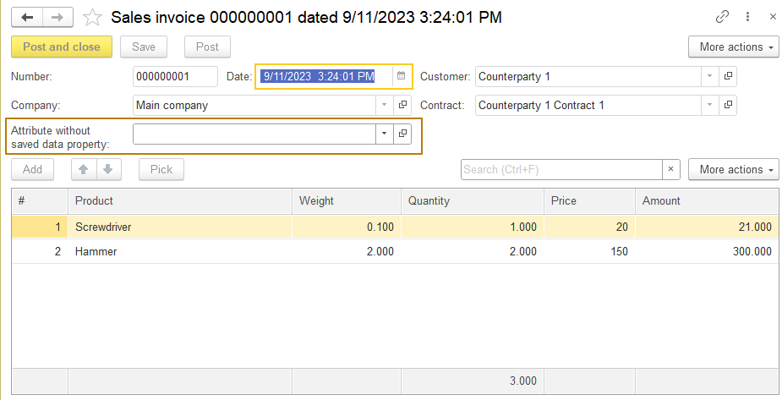
Only an attribute with disabled "Saved data" property is available for editing.
Radio buttons and checkboxes
If a field of the Radio button field kind is inserted, then the ”ChoiceList” property of form item determines the number and values of radio buttons. The horizontal location of radio buttons is used by default. To arrange them vertically, change the value of the ”Column count” property. If the number of columns is set to 0, then the system can arrange the radio button items in several lines, selecting the number of the radio button items per line, based on the free space on the form. Selection is not performed dynamically, rather at the time of form creation.
For the fields of the Checkbox field and Radio button field kinds, you can specify a display kind. For checkbox fields, use the Checkbox type property. Checkbox fields can be represented as segmented buttons, switches, or checkboxes.
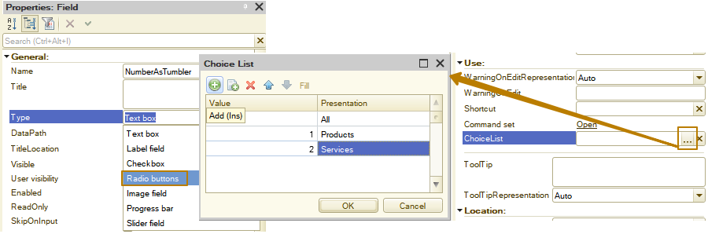

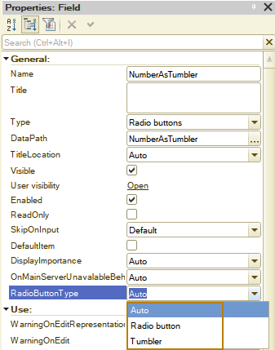
The first three elements: checkboxes with different values for the checkbox type property. Next two: radio buttons with different values for the "radio button type" property.
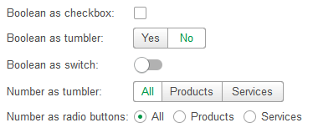

Group
When you develop a form, you can combine items in various ways. You can combine fields, form pages, commands, and columns.
A form can contain groups of controls. These can be field groups, pages, and command groups. You can also create column groups for the Table type items.
In the editor, you can create groups of the following types:
- Regular group. Intended for combining form items.
- Command bar. A form item designed to accommodate buttons and groups.
- Pages. This group is intended for organizing a panel with tabs. Tabs can be located both vertically and horizontally. To add pages to such a panel, add as many nested groups as the page should have on the panel. Inside the group of the Pages kind, there can be only groups of the Page kind, which are the groups of a special kind intended to form panel pages. This group may contain other nested items.
- Column group. Allows you to combine columns in a table. With this kind of group, you can change the column grouping rule (vertical or horizontal grouping).
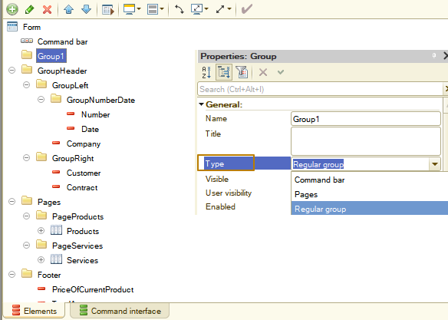
Groups can be nested. You can move form items between groups. This automatically determines the admissibility of such a transfer. If the transfer requires changing any item properties (for example, View), the change is performed automatically. If, as a result, the requirements to subordinate items change, they are either automatically changed or deleted.
A regular group can have different design options:
- No. A group is not specifically marked up.
- Slight highlight. The group title is displayed in a large green font.
- Standard highlight. The group title is displayed in a large green font. Indents are formed around the group items (on each side).
- Strong highlight. The group title is displayed in a large green font. On the left side (for the entire height of a group) a green band is formed. An indent is formed from below.
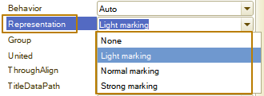

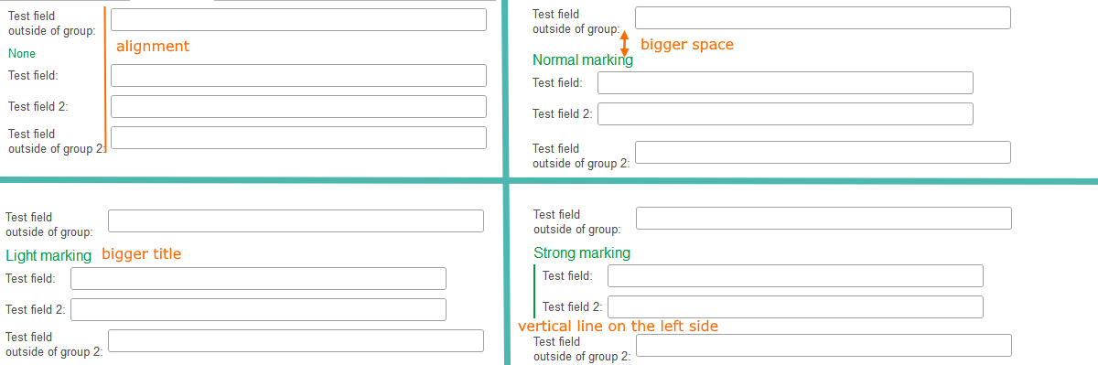
A standard group can be configured so that the user (in 1C:Enterprise mode) can collapse or expand the group. For example, there is a possibility to place information in a collapsible group that is not important when working with a form on a regular basis but may sometimes be required for viewing and analysis.
The behavior of the group is determined by the Behavior property:
- Standard group. For such a group, the Behavior property is set to Regular (or Auto). This group does not change its display in any way during user actions (except for programmatic modification of the composition and the external view of the group and its items).
- Collapsible group. For such a group, the Behavior property is set to Collapsible. Such a group can be collapsed or expanded by the user in 1C:Enterprise mode. A developer cannot determine the current state of the group from 1C:Enterprise language, he also cannot forcibly collapse or expand a group. The initial state of a group is determined by the Collapsed check box. A group cannot be collapsed or expanded if its title is empty or not displayed (ShowTitle property has False value).
- Pop-up group. For this group, the Behavior property is set to Pop-up. In the initial state a pop-up group is displayed in the same way as a collapsed group. When the heading of such a group is clicked, the group "pops up" over the parent form in a special window. At each time point on a form there can be only one pop-up group. This implies that pop-up groups cannot be nested. The nested popup group will appear as a collapsible group. Showing and hiding a pop-up group does not require a server call.
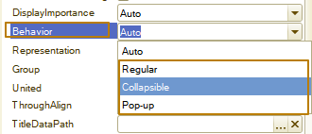
A user can manage the state of a collapsible group (collapsed or expanded) using a special image or hyperlink. To set the state control item, use the ControlRepresentation property. You can also set the group title (the CollapsedRepresentationTitle property) that will be displayed if the group is in the collapsed state. If the Collapsed title property is not filled, then the normal group title will be displayed in the collapsed state.
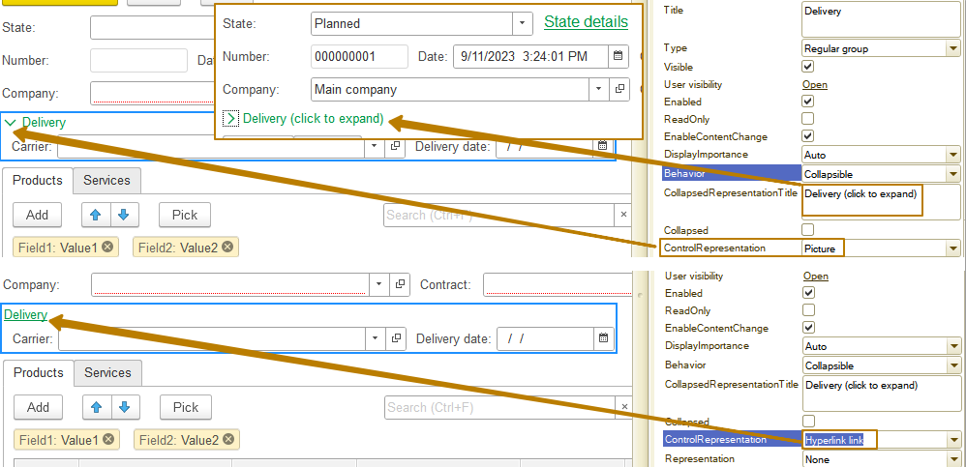
A pop-up group must have a title. Without a specified title, a pop-up group behaves like a standard group. A title acts as a text of the hyperlink clicking on which leads to displaying the window with the contents of a group.
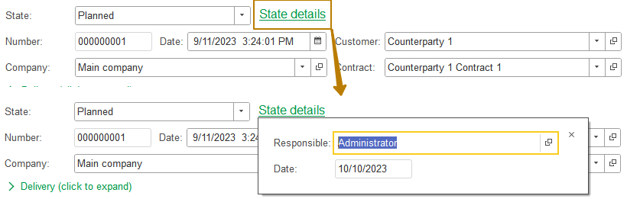
The ”Command source” property of the Command bar defines a form item (Form as well as form items of the ”Form table” type and the ”Spreadsheet document field” or ”Graphical schema field” types) that will provide "own" commands for display in the command bar. A composition of commands for display in a command bar is defined by the property Command set of the form item commands that is a source of commands.
For example, we have a form with an attribute of the “SpreadsheetDocument” type, into which we output a print form or report data. To make it more convenient for a user to use some commands of a spreadsheet document, we need to add a group with the “Command Bar” type and indicate the source of the commands - our spreadsheet document.
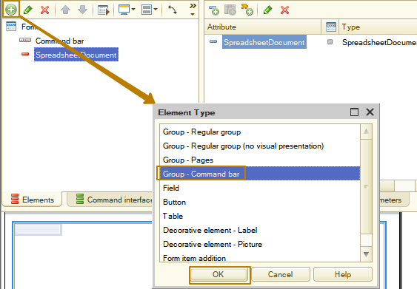
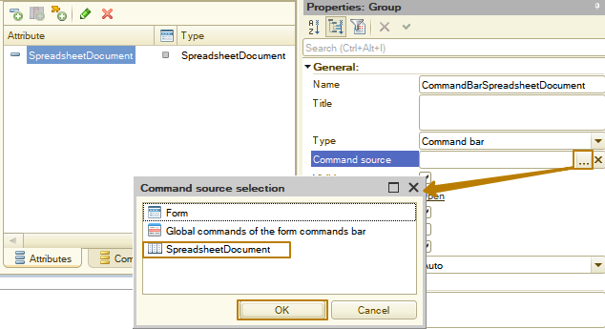
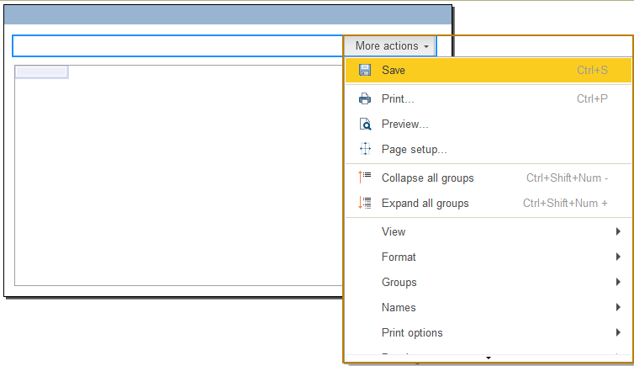
Usually we don’t have to make these steps for form tables, because they have a built-in command bar. We add our own command bar for tables when we need to do something non-standard, for example, place it to the left of the table, and place the buttons vertically or separate it from the table by moving it to another place in the form.

Conditional appearance
The form allows to set conditional appearance of the form items. The data composition system (reports and dynamic lists) also contains conditional appearance. Calling the conditional appearance settings is available from the properties panel of the root item of a form. It is not recommended that you use the conditional appearance of a form for designing dynamic lists if such appearance can be obtained by setting up the conditional appearance of the list itself.
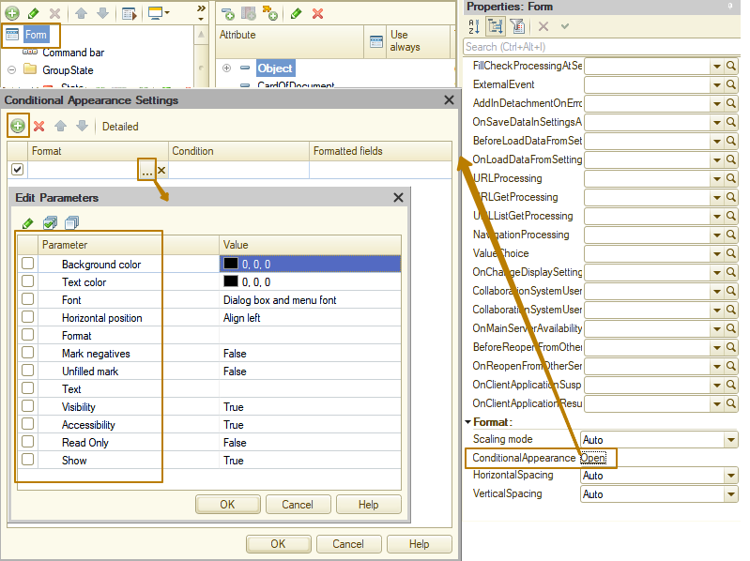
The following conditional appearance kinds are available:
- Background color. Allows you to change the background color and used for:
- Form items: input field, text document field, table, and standard button.
- Table fields: label field, input field, radio button field, and picture field.
- Text color. Allows you to change the text color and used for:
- Form items: label field, input field, text document field, picture field, radio button field, table, regular button, hyperlink, text decoration, and picture decoration.
- Table fields: label field, input field, and radio button field.
- Font. Allows you to change the font and used for:
- Form items: label field, input field, text document field, picture field, radio button field, calendar field, table, regular button, hyperlink, text decoration, and picture decoration.
- Table fields: label field and input field.
Note: Changing the font of a form item using conditional appearance is not considered when determining the size of items.
- Mark negatives. Allows you to set the highlighting of negative values. Used for the following form items: label field and input field. Used for the following table fields: label field and input field.
- Horizontal position. Specifies the horizontal position of the value and used for:
- Form items: label field, input field, and text decoration.
- Table fields: label field and input field.
- Unfilled mark. Allows you to set the mark of an empty value and used for:
- Form items: input field, table.
- Table fields: input field.
Note: If you manage the MarkIncomplete property using conditional appearance, then it is recommended that you set the AutoMarkIncomplete property to “No” for the field to be designed.
- Text. Used to set text and applies to the following table fields: label field and input field.
- Format. Allows you to change the value output format and used for:
- Form items: Page group and Regular group group.
- Table fields: label field and input field.
- Visibility. Hides the following table fields: label field, input field, radio button field, and picture field. Hidden cells are replaced with adjoining cells that become larger. An algorithm for stretching cells may vary in different client applications.
To manage the visibility of a column included in a group with the In cell column grouping, use the Show conditional appearance kind. You can find its description below.
It is not recommended that you use conditional appearance to hide entire rows in a table. Using conditional appearance to hide rows can have a negative impact on performance and result in incorrect display of the table contents.
- Accessibility. Disables availability of the following table fields: label field, input field, radio button field, and picture field.
- Read only. Enables the View only mode for the following table fields: label field, input field, radio button field, and picture field.
- Show. Hides the following values in a table column: label field, input field, radio button field, and picture field. This conditional appearance kind is recommended when you need to hide a table column that is located in a column group with the In cell grouping. If you need to hide columns that are not grouped with other columns or remain visible in separate table columns upon grouping, use the Visibility conditional appearance kind.
Note: For conditional appearance, the current computer date adjusted for the time zone of the 1C:Enterprise session is used.
If a column of a form table is formatted using conditional formatting, and the condition contains an attribute field displayed by the formatted table, then when calculating the condition, the current data of the table to which the formatted column belongs is used. If the field being formatted does not belong to a table, then the current data of the first (in the order of placement in the form editor) table of the form is used to calculate the condition.
With conditional appearance, you can set some types of appearance of the form items depending on the values of the form attributes, while the design of the form will be dynamic, that is, it will consider changes in the form data. No special action is required to change the form appearance. If dynamic list fields are used for conditional form appearance, set the Always use property for these fields.
For example, we can configure the text color to change in the rows of the Products table if the amount in the row is more than 1 million.
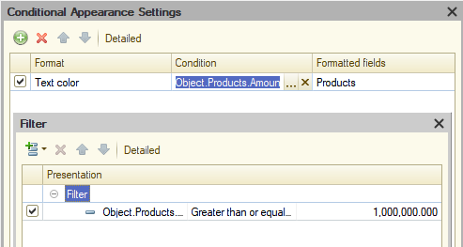
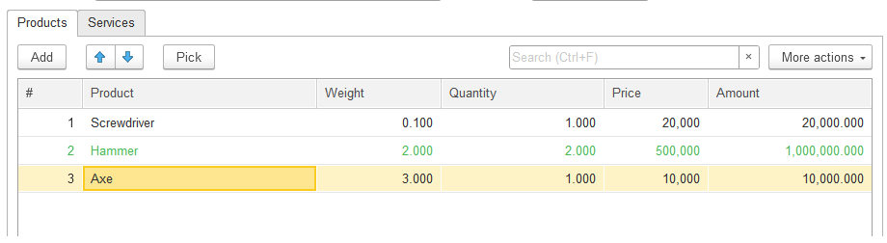
Home page
The Home page is the active form when the application is launched and is used to locate frequently used user functions. By default, the composition of the home page is configured by the developer; it can be common for everyone or can depend on user roles.
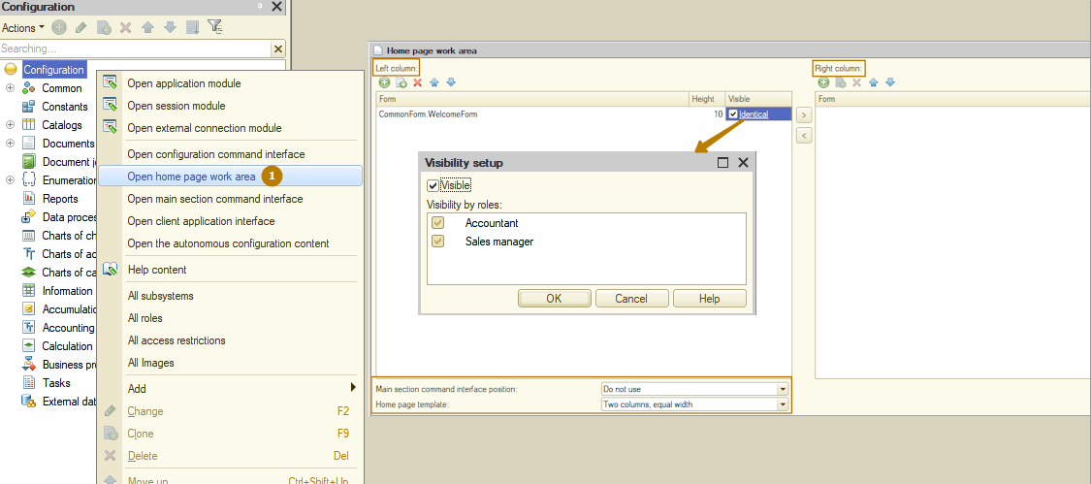
This is what it looks like for a user:
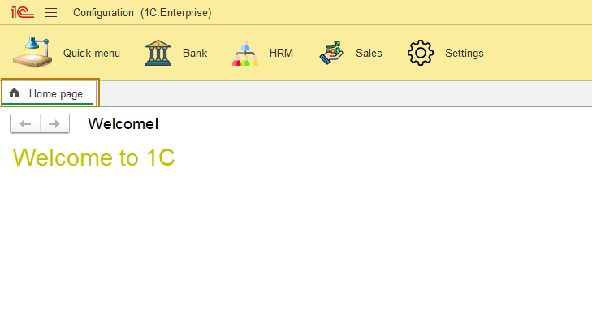
Each user can change the composition of the home page in Enterprise mode.
